

Foundations of Programming

Lab Assignment No. : 03

PROBLEM STATEMENT:
Write a program in C to generate multiplication tables for a given number.
OBJECTIVES:
- To understand the use of looping statements in C.
- To generate multiplication tables using loops.
- To improve program logic and execution flow understanding.

THEORY:
Syntax for for loop example program
Syntax=for (initialization; condition; increment/decrement)
Example= #include <stdio.h>

int main()
{
int i;

for (i = 1; i <= 5; i++)
{
printf("%d\n", i);
}

return 0;
}

Syntax for while loop example program
Syntax= Syntax for while loop example program
Example= #include <stdio.h>

int main()
{
int i = 1;

while (i <= 5)
{
printf("%d\n", i);
i++;
}

return 0;
}
Syntax for do while loop example program
Syntax= do
{
// statements
}
while (condition);
example = #include <stdio.h>

int main()
{
int i = 1;

do
{
printf("%d\n", i);
i++;
}
while (i <= 5);

return 0;
}
ALGORITHM:

Type Program (Multiplication table)

PLATFORM:
Linux

INPUT:
#include <stdio.h>

int main()
{
int num, i;

printf("Enter a number ");
scanf("%d", &num);

printf("\n Table of %d\n", num);

for (i = 1; i <= 10; i++)
{
printf("%d x %d = %d\n", num, i, num * i);
}

return 0;
}
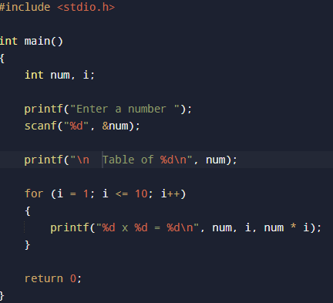
OUTPUT:

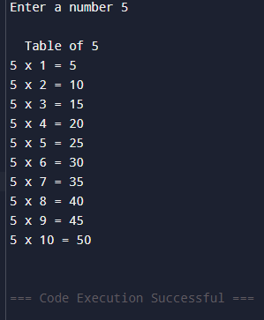
CONCLUSION:
Thus, the menu driven program in C successfully performs basic arithmetic operations using switch–case statements.

FAQs:
- Which loop is best suited for generating multiplication tables?
- What is the role of loop initialization?
- Difference between for loop, while loop and do while loop?
- Can a do–while loop be used to generate multiplication tables? Explain.
- Why is the do–while loop called an exit-controlled loop?

